**Project Based Learning REPORT ON**

**“Covid-19 Data Display”**

# SUBMITTED BY

**MANSI BALASAHEB AHER (FP15)**

**SAKSHI KISHOR KOTHURKAR (FP08)**

**PRANITA PRASHANT DIDDI (FP19)**

## Content

|  |  |  |
| --- | --- | --- |
| Sr. No. | | Title |
| **1** | | **Introduction** |
|  | 1.1 | Introduction Covid-19 |
|  | 1.2 | Problem Statement |
| **2** | | **Data** |
|  | 2.1 | Data Source |
|  | 2.2 | Data description |
| **3** | | **Data Display Python Program and ANALYSIS** |
| 3.1 | | Python Program to display the data in graph |
| 3.2 | | Program output displaying the graph |
| 3.3 | | Python Program to display the data in BAR graph for state compare |
| 3.4 | | Program output displaying the state wise BAR graph |
| **4** | | **Conclusion And Future Work** |
|  | 4.1 | Conclusion |
|  | 4.2 | Future Enhancement |
|  | 4.3 | website |

**1: INTRODUCTION**

**1.1 INTRODUCTION COVID-19:**

Coronavirus disease 2019 (COVID-19) is an infectious disease caused by severe acute respiratory syndrome coronavirus 2 (SARS-CoV-2). It was first identified in December 2019 in Wuhan, China, and has resulted in an ongoing pandemic. The first case may be traced back to 17 November 2019.

The virus is primarily spread between people during close contact, most often via small droplets produced by coughing, sneezing, and talking. The droplets usually fall to the ground or onto surfaces rather than travelling through air over long distances. Less commonly, people may become infected by touching a contaminated surface and then touching their face. It is most contagious during the first three days after the onset of symptoms, although spread is possible before symptoms appear, and from people who do not show symptoms.

7

The Covid infection and spreading data for India is available and we decided to plot that data using Python for study and displaying pictorial format.

**1.2 PROBLEM STATEMENT:**

In this project we tried to display Covid data of India and States in Line graph format and Bar graph format. This display should help the use for understanding the extent and spread of Covid 19 over the time. User should be able to select which data he want to display with menu option and that data should be displayed for analysis and understanding.

This analysis mainly focuses on:

* What is the current COVID-19 situation in India?
* State-wise comparison.
* Datewise Covid 19 numbers as New, Confirmed, Deceased, Recovered.

8

* For particular date display the active patient data and compare between different states

**2 : DATA**

**2.1. DATA SOURCES**

9

For the COVID-19 data we have taken excel data from website [**https://api.covid19india.org**](https://api.covid19india.org). this website has various data. For our project we have taken the state wise data for displaying the graphs.

Below image is from the site which shows the data that we have downloaded for this project

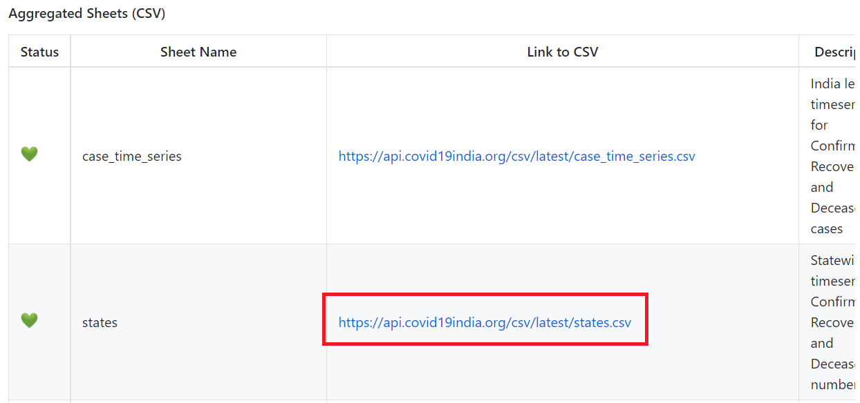

For facts and information, we have referred www.wikipedia.com and <https://www.mohfw.gov.in/>

**2.2**  **Data Description :**

The downloaded is in the excel format and comma separated. Every line has new record and each record has below columns

* Date
* State
* Confirmed
* Recovered
* Deceased
* Other
* Tested

For this project we have used columns Date, State, Confirmed, Recovered and Deceased.

To calculate the New-Cases for each date we have used formula (Confirmed – Recovered) of that date. The data in file is from 01-01-2020 to 26-07-2021 date.

The data in the excel is look like below

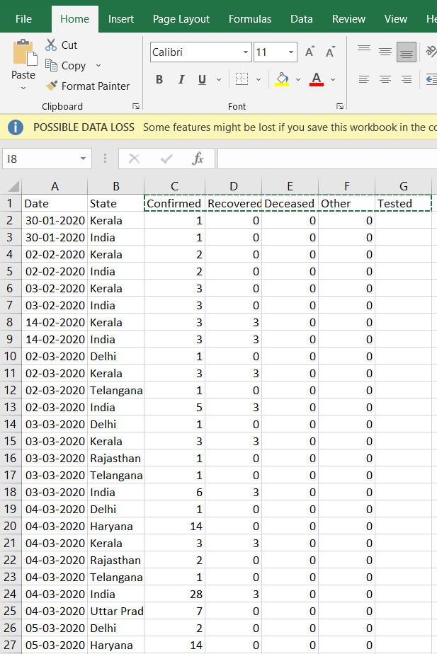

**3. Data Display Program and ANALYSIS**

India recorded its first COVID-19 case on 30th January 2020 in kerala. The infected person was a student who had travelled to china for academic purpose. And since then cases in India is rising exponentially.

**3.1 Python Program to display the data in graph**

For displaying this data we used python to read the file data.we used the Pandas library for data read and filtering. For plotting the graph we have used the matplotlib library.

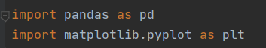

We used DataFrame to read the State.csv file and store the data in data frame of pandas library



Menu is displayed to the user to select the data

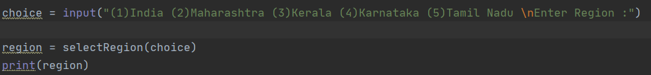

User input is processed in function to select the state name

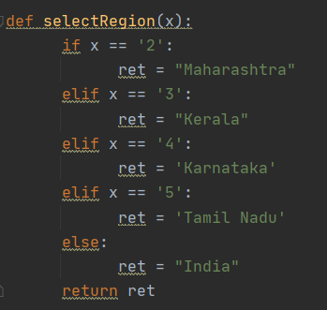

Data is filtered as per user choice in “region” variable and date range. New column “NewCount” is added as subtraction of columns “Confirmed” and “Recovered”



Created the x axis data y axis data from this filtered data column values. This x and y axis data is given to matplotlib.pyplot.plot() method to display the data in graphical format. And the graph is displayed.

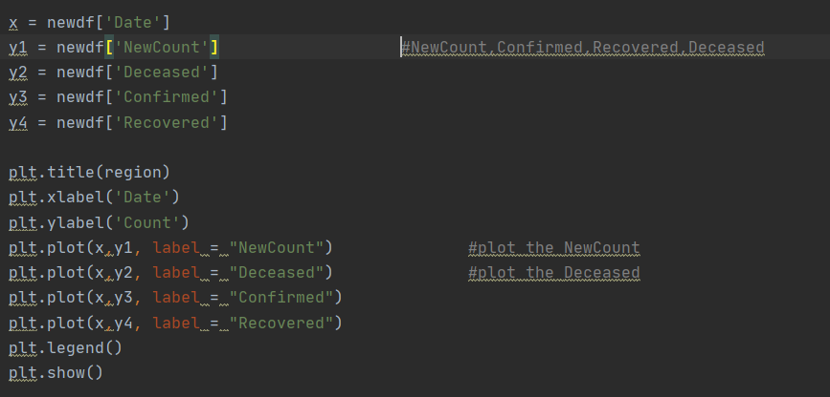

**3.2 Program output displaying the graph**

a) User selects to display “India” Data

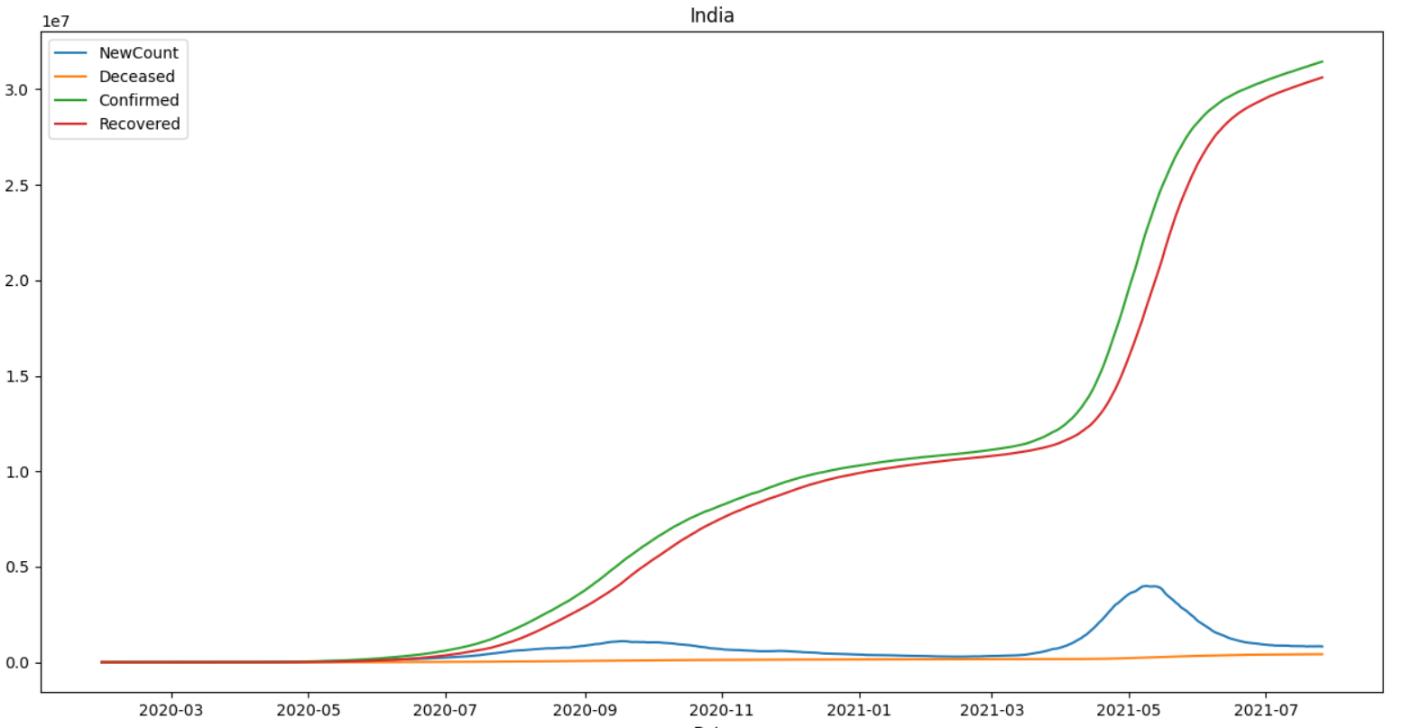

b)User selects to display “Maharashtra” Data

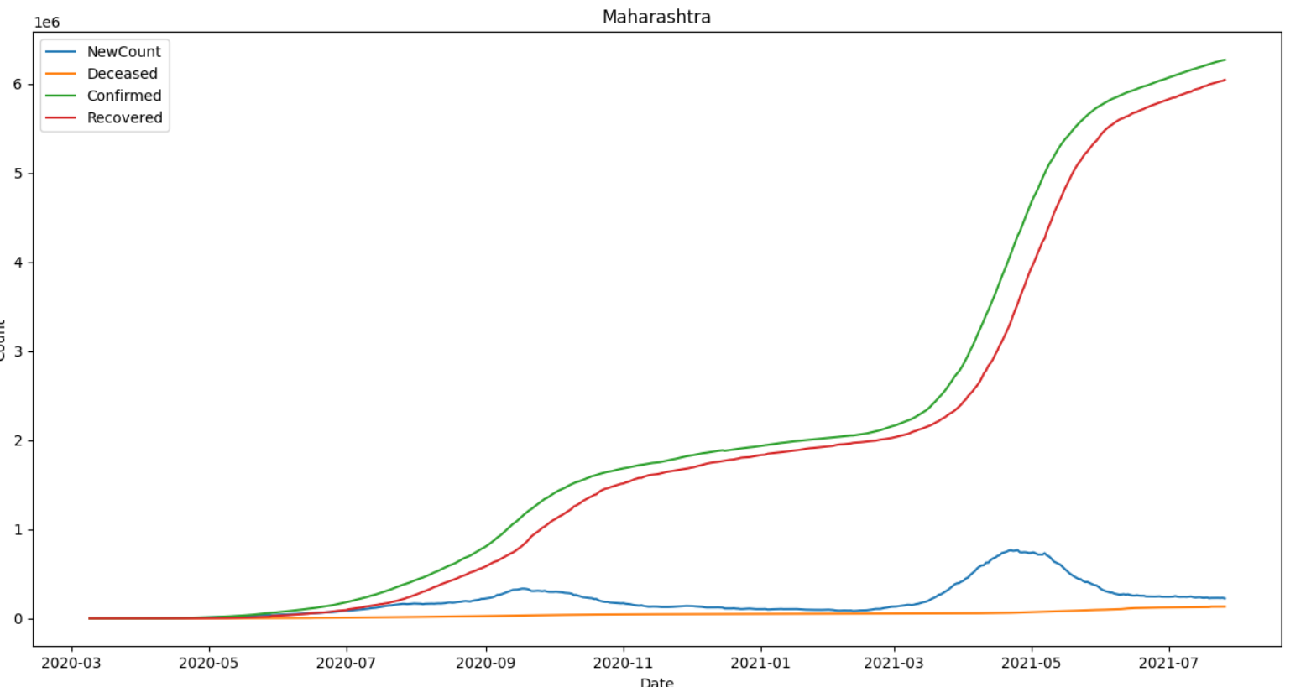

c) User selects to display “Kerala” Data

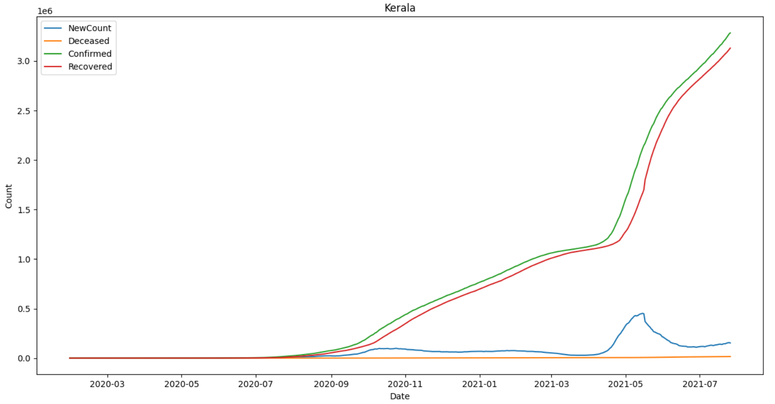

**3.3 Python Program to display the data in BAR graph for state compare**

Read the data and filter the data for particular date”26-07-2021”. Create new column “NewCount” and sort the data as per “NewCount”

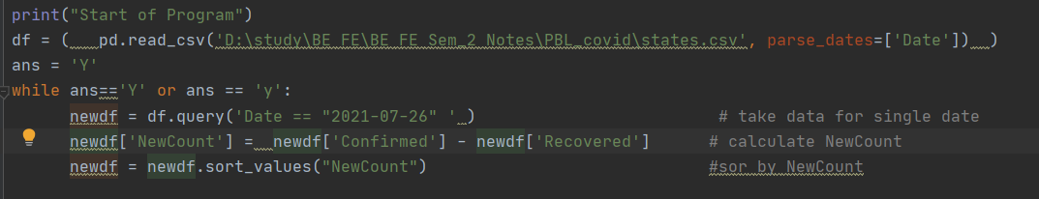

Take the “State” values on X axis and “NewCount” values on the Y axis and display the data in bar format using matplotlib library. User can compare the state wise data for count.

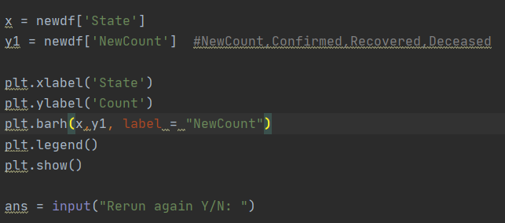

**3.4 Program output displaying the state wise BAR graph**

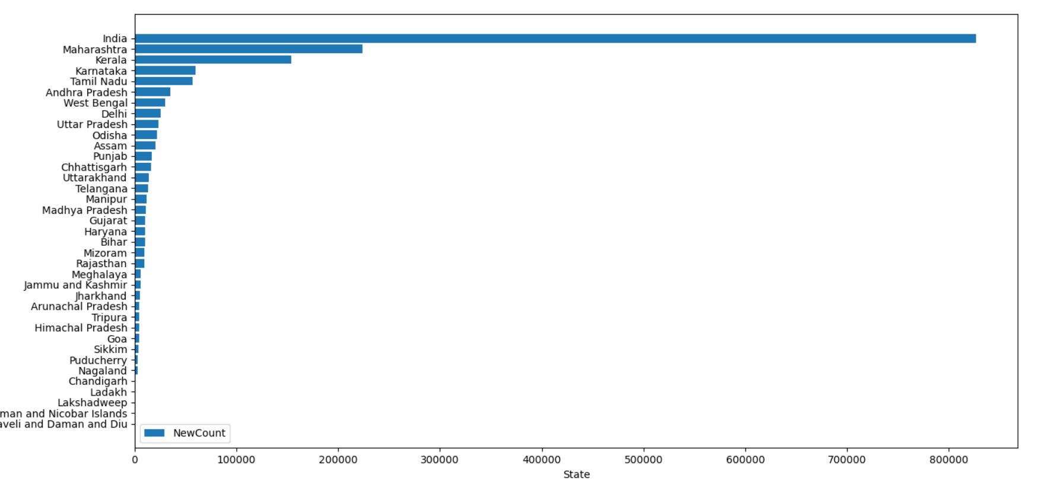

As shown above, Maharashtra, Kerala, Karnataka, Tamil Nadu, Andhra Pradesh,

West Bengal are top 6 states in confirmed cases in India.

When the cases started to be detected in

India since that time only Maharashtra has been leading this tally. As of 26 July 2021, over 62.9 lakh cases are confirmed in Maharashtra.

|  |  |
| --- | --- |
|  | **4 : CONCLUSION AND FUTURE WORK**  4.1 Conclusion   * India is now 6th largest confirmed cases of COVID-19 in the world. * India has not reached the peak yet so as of now we cannot predict the approximate number of confirmed cases in India. * Recovery rate of India is also showing exponential behaviour same as confirmed cases. But if cases increase beyond certain point, then thing can go out of control which will affect the recovery rate. * Gender information of most of the patients is not released by the government. * Same as gender, age information is unavailable for most of the patients, but whatever data is available shows age and cases are normally distributed and 21-40 is the age bin which has been infected more. * India was in lockdown for more than 2 months but still situation did not get any better. This may be due to weak administration or the violation of lockdown by citizens. |

### 4.2 FUTURE ENHANCEMENT

**1.Prediction Model**

India has not reached the peak yet, once it reaches the peak the prediction model can be built to show that how much time it will take to get things back to the normal.

**2. Vaccination Data**

India vaccination data is available on <https://www.cowin.gov.in/> this data can be used to plot the vaccination graphs of each state and predict when each state will complete the vaccination and what will happen if speed of vaccination is increase or decrease.

**3. Sentiment Analysis**

India has never experience such pandemic in last 100 years so what do people think about this pandemic, lockdown , government approach/policies etc can be studied to have sentiment insight of this pandemic.

4.3 WEBSITE

<https://api.covid19india.org>

<https://www.w3schools.com/python/>

<https://pandas.pydata.org/pandas-docs/stable/getting_started/tutorials.html>

<https://pandas.pydata.org/pandas-docs/stable/user_guide/10min.html>

<https://www.w3schools.com/python/pandas/default.asp>

<https://www.tutorialspoint.com/python_pandas/index.htm>

<https://www.datacamp.com/community/tutorials/pandas-tutorial-dataframe-python>

<https://www.w3schools.com/python/pandas/pandas_dataframes.asp>

<https://www.tutorialspoint.com/python_pandas/python_pandas_dataframe.htm>

<https://www.w3schools.com/python/matplotlib_intro.asp>

<https://pandas.pydata.org/docs/getting_started/intro_tutorials/04_plotting.html>

<https://www.tutorialspoint.com/matplotlib/index.htm>

<https://www.geeksforgeeks.org/matplotlib-tutorial/>

<https://www.youtube.com/watch?v=mKSWAlvXSmw>

<https://www.youtube.com/watch?v=cMp8voa0tLc>

<https://www.youtube.com/watch?v=voLSnXi4hAI>

<https://en.wikipedia.org/wiki/COVID-19>

<https://www.mohfw.gov.in/>